Arkansas BEAD Program Subgrant Agreement

SUBGRANT AGREEMENT

THIS SUBGRANT AGREEMENT (the “Agreement”) is made and entered into as of the ___ day of [month, year] (the “Grant Date”) among the Arkansas State Broadband Office (the “ASBO”), an office in the Arkansas Economic Development Commission, and subgrant recipient, [Name of award recipient, including any dba] (the “Subgrantee”), (collectively, the “Parties”).

WITNESSETH

WHEREAS, the ASBO is authorized to make Grant Funds (as defined below) available to qualified recipients under the BEAD Grant Program (as defined below) to deploy broadband to all unserved and underserved locations within the State of Arkansas;

WHEREAS, the ASBO has determined, based on Subgrantee’s Application (as defined below), that Subgrantee has the financial, technical, operational and managerial capabilities to successfully deploy broadband infrastructure, as per BEAD Grant Program requirements;

WHEREAS, the Arkansas State Broadband Director has approved the granting of a fixed amount of funds through this Agreement from the ASBO to Subgrantee;

WHEREAS, Subgrantee has agreed to cause the installation of certain broadband facilities and to provide broadband services, as described more specifically in Exhibit A, and to comply with all terms and conditions of the BEAD Grant Program; and

WHEREAS, the ASBO has determined and Subgrantee agrees that this award is a “fixed amount subaward,” as defined in 2 CFR § 200.201, for which the major purpose of the subaward is a broadband infrastructure project.

NOW, THEREFORE, in consideration of the mutual promises contained herein, the Parties hereby agree as follows:

- Definitions. All capitalized terms used herein and not otherwise defined in this Agreement shall have the same meaning ascribed thereto in the BEAD NOFO (as defined below).

  - “Applicable Regulations” means all State and federal laws, rules, regulations, and guidance applicable to the BEAD Grant Program, and all amendments and supplements thereto, including but not limited to 47 U.S.C. § 1702, the BEAD NOFO, the Department deadlof Commerce Standard Terms and Conditions, the General Terms and Conditions for the BEAD Program, the Specific Award Conditions applicable to the State of Arkansas’ BEAD award, the Proposal, and any program rules promulgated by the Arkansas Economic Development Commission.

  - “Application” means Subgrantee’s BEAD Application attached as Exhibit A and incorporated herein by reference, and includes all documents and information provided to the ASBO through the ARConnect Grantor Portal or other written communication by or on behalf of Subgrantee in connection with Subgrantee’s request for Grant Funds from the BEAD Grant Program, including the pre-registration application and bid application, and includes any official communication from the ASBO related to Subgrantee’s award of Grant Funds, which may include terms and conditions that are different from, or in addition to, those proposed in the Application. In the event the ASBO awards more than one of Subgrantee’s Applications, the term “Application” shall refer to each individual application as if the Parties entered into a separate subgrant agreement for each Application. The “Application” does not include any of Subgrantee’s proposals that are no longer applicable under subsequent Applicable Regulations. The “Summary of Application” in Exhibit A shall be considered part of the “Application” and shall control over any inconsistencies between the Summary of Application and the Application.

  - “BEAD Grant Program” means the grant program funded by the Broadband Equity, Access and Deployment (“BEAD”) program established in the Infrastructure Investment and Jobs Act, Pub. L. 117-58, 135 Stat. 429, 70901-70927, and includes the State of Arkansas’ rules and grant program to award the State’s BEAD funding to subgrantees, as the Act or rules may be amended from time to time.

  - “BEAD NOFO” means the National Telecommunications and Information Administration’s (“NTIA”) BEAD Notice of Funding Opportunity and includes any Policy Notice or Waiver issued by NTIA relating to the BEAD Grant Program.

  - “Broadband Project” or “Project” means the planned and actual installation of broadband facilities and provision of services in the area and to the BSLs as set forth in the Application.

  - “Broadband Serviceable Location” or “BSL” is a geolocation in the Broadband Serviceable Location fabric established under 47 U.S.C.A. § 642 (b)(l)(B) within the scope of the Application where fixed broadband internet access service is, or can be, installed.

  - “Eligible Costs” means allowable costs under the BEAD Grant Program and Applicable Regulations that are reasonable, necessary, allocable, and allowable for the Broadband Project or other eligible activity, conform to generally accepted accounting principles, and are not unallowable or ineligible costs under Applicable Regulations.

  - “Federal Grants Officer” means the National Institute of Standards and Technology (NIST) Grants Officer or other entity designated to serve as the Grants Officer for the BEAD program.

  - “Federal Interest Period” means the period during which Subgrantee will hold in trust for the beneficiaries of the BEAD Grant Program all real property and equipment acquired or improved in connection with this Agreement, which period begins upon the acquisition or improvement of the real property and/or equipment and continues for ten (10) years after the year of the Project Closeout Date. For example, if the Project Closeout Date is in 2027, regardless of the month, the Federal Interest Period will last until December 31, 2037.

  - “Grant Funds” means funds disbursed to the Subgrantee pursuant to the award for the Broadband Project as specified in the Summary of Application attached as Exhibit A.

  - “Matching Funds” means cash or in-kind contributions provided by Subgrantee or a third party or parties to meet the BEAD Grant Program’s non-federal match requirement.

  - “Performance Measurement Policy Notice” means the “Broadband Equity, Access, and Deployment (BEAD) Program: Performance Measures for BEAD Last-Mile Networks Policy Notice” issued on September 19, 2025, and includes any subsequent versions, modifications, or additional guidance issued by NTIA.

  - “Project Closeout Date” shall be the date described in Section 8.A(ii).

  - “Project Area” means the Project Area Footprint (as defined in the Proposal consisting of identified Broadband Serviceable Locations and Community Anchor Institutions) that will be serviced as part of the NTIA-approved award to Subgrantee, as listed in the Summary of Application.

  - “Project Costs” means the approved costs of the Broadband Project as established in the Application, subject to allowable uses of Grant Funds as set forth in the Applicable Regulations and this Agreement.

  - “Proposal” means ASBO’s BEAD Initial and Final Proposals as approved by NTIA.

  - The definitions in the BEAD NOFO and 2 CFR Part 200 shall apply to capitalized terms not otherwise defined herein.

- Grant. Upon the acceptance of this Agreement by all Parties, the ASBO agrees to pay Subgrantee up to the total amount of the Grant Funds, subject to all terms and conditions of this Agreement. The Parties acknowledge and agree that in the event the ASBO awards more than one of Subgrantee’s Applications, this Agreement shall apply to each Application as if a separate subgrant agreement has been executed for each awarded Application, and the ASBO may enforce the provisions of this Agreement separately and independently for each Application and associated Broadband Project. The total amount of all awarded Grant Funds from each awarded Application will be set forth in Appendix 1, Federal Award Identification.

- Purpose and Compliance.
  - Purpose. The sole purpose of the Grant Funds is to provide funds for Subgrantee to expend on the Broadband Project for the deployment of broadband facilities and services within the Project Area as set forth in the Application. Subgrantee shall not use the Grant Funds for any other purpose, nor shall Subgrantee use the Grant Funds in any manner that is inconsistent with Applicable Regulations.
  - Compliance with Applicable Regulations. Subgrantee shall perform all obligations under this Agreement in compliance with all Applicable Regulations. In any case where language among two or more Applicable Regulations appears inconsistent, the Parties agree that the Applicable Regulations shall be read and interpreted in a manner which emphasizes consistency and harmonization across all Applicable Regulations. Where harmonization is impossible, that Parties agree to prioritize following the language contained in the Applicable Regulations in the following order (from highest to lowest priority): 47 U.S.C. § 1702; the award’s Specific Award Conditions; the General Terms and Conditions for the BEAD Program; the BEAD NOFO; the Department of Commerce Standard Terms and Conditions. In the event of a conflict between the terms of this Agreement and any Applicable Regulations, the terms of the Applicable Regulations shall prevail.
  - Contractors and Subcontractors. Subgrantee shall cause, and shall be responsible for ensuring that, its contractors and subcontractors that perform any work or services related to the Project comply with all Applicable Regulations. Subgrantee shall monitor contractors’ and subcontractors’ compliance with Applicable Regulations. Subgrantee shall at all times be responsible for full compliance with the terms and conditions of this Agreement and is fully responsible for the acts and omissions of all contractors and subcontractors.
  - Specific Conditions. The ASBO reserves the right to impose specific award conditions in accordance with 2 C.F.R. § 200.208 or require additional monitoring of Subgrantee activities based on the results of a pre-award risk assessment, a post-award monitoring review, or failure to meet Subgrantee’s network speed and latency minimum standards as set forth in the Performance Measurement Policy Notice. Monitoring activities shall be conducted in accordance with the procedures set forth in the BEAD Program Monitoring Plan and network performance measurement activities will be conducted in accordance with the Performance Measurement Policy Notice. Subgrantee shall cooperate fully with all monitoring protocols and provide timely access to records, personnel, and facilities as requested by the ASBO or its designees. Failure to comply with specific award conditions or monitoring requirements may result in delayed payments, suspension of disbursements, or other remedies as provided under this Agreement and Applicable Regulations.

- Use of Grant Funds.
  - Project Costs. Subgrantee shall use the Grant Funds solely for Eligible Costs directly incurred for the Broadband Project, and in strict compliance with the provisions of this Agreement and Applicable Regulations. Subgrantee may use the Grant Funds to deploy broadband infrastructure in or through any area required to reach interconnection points or otherwise to ensure the technical feasibility and financial sustainability of the Broadband Project.
  - Restrictions. Subgrantee acknowledges and agrees to the following restrictions on the use of Grant Funds by Subgrantee and any of its contractors or subcontractors:
    - Political Activity. No portion of the Grant Funds will be used for any partisan political activity or to further the election or defeat of any candidate for public office or influence the approval or defeat of any ballot issue.
    - Prohibition Against Payment of Bonus or Commissions. No portion of the Grant Funds will be used in payment of any bonus or commission for the purpose of obtaining approval or concurrence under this Agreement.
    - Profits and Fees. A profit, fee, or other incremental charge above actual cost incurred by Subgrantee is not an allowable cost. Subgrantee may retain Project income without restriction, including retaining Project income for profit.
    - Collective Bargaining. No portion of the Grant Funds will be used directly or indirectly to support or oppose collective bargaining.
    - Prohibited Equipment and Services. No portion of the Grant Funds will be used to purchase or support any communications equipment or service covered by either the Secure and Trusted Communications Networks Act of 2019 (47 USC § 1608) or 2 CFR § 200.216, or to purchase or support fiber optic cable and optical transmission equipment manufactured in the People’s Republic of China.
  - Period of Performance.
    - Time is of the essence for this project. Subgrantee shall deploy the broadband network as described in the Broadband Project and begin providing broadband service to each customer that desires broadband service within the timeline set forth in the Application, and in no event later than four (4) years from the Grant Date, unless the ASBO extends the date as provided in subsection (ii) of this Section 4.C.
    - The ASBO may, in its sole discretion, extend the deadline under this subparagraph for up to one (1) year if: (1) Subgrantee has a specific plan for use of the Grant Funds, with project completion expected by a specific date not more than one (1) year after the four-year deadline; (2) the construction project is underway; or (3) extenuating circumstances require an extension of time to allow the project to be completed. An authorized representative of Subgrantee must submit a written request for an extension, in the form and format requested by the ASBO, and any documentation requested by the ASBO. Subgrantee’s request must be approved in writing by an authorized representative of the ASBO and is subject to consultation with NTIA and the approval of the Assistant Secretary of Commerce for Communications and Information.

Subgrantee’s Responsibilities To Deploy Broadband Facilities and Provide Broadband Service.
- Subgrantee shall at all times comply with all Applicable Regulations and applicable federal, State and local laws, rules, and regulations, including environmental and historic preservation compliance requirements detailed in Exhibit E and the General Terms and Conditions for the NTIA BEAD Program Funds included in Exhibit F. Subgrantee acknowledges and agrees that obligations in Applicable Regulations requiring the ASBO, as an Eligible Entity, to impose requirements or obligations on subgrantees, or to ensure compliance by subgrantees, shall apply to Subgrantee as if such obligations are fully set forth herein.
- All work on the Broadband Project shall conform to the plans described in the Application, including but not limited to the financial, managerial, operational, and technical capabilities described in the Application, unless the ASBO, in its sole discretion, provides written approval to deviate from the Application. Any modification to the budget that changes any cost category, inclusive of both Grant Funds and Matching Funds, by more than 10% of the original line item requires written approval by ASBO.
- Subgrantee shall deploy the Broadband Project in accordance with the deployment commitments set forth in the Application, including all plans, timelines and other specifications. Subgrantee shall immediately notify the ASBO of any material deviation or delay in the deployment commitments, including following Subgrantee’s completion of Project artifacts included in the first two (2) Deployment Milestones, as defined in Exhibit B. Subgrantee shall cooperate with any periodic progress inspections by the ASBO or its designee.
- Subgrantee shall make a good faith effort to conduct at least one (1) public project groundbreaking ceremony and one (1) ribbon cutting ceremony in connection with the Broadband Project during the Period of Performance. Such events shall be intended to publicly acknowledge the corresponding commencement of construction activities and the conclusion of construction activities along with the investment of BEAD Grant Program funds. Subgrantee shall provide the ASBO with reasonable advance notice of any such ceremonies and shall reasonably cooperate with the ASBO regarding participation, coordination, or public communications related to the ceremonies. Such events may be conducted at no cost to Subgrantee. Any costs incurred by Subgrantee in connection with a project groundbreaking or ribbon cutting ceremony, including but not limited to event production, staging, materials, marketing, or related outreach expenses, shall not constitute Eligible Costs and shall not be charged to or reimbursed with Grant Funds.
- For each county in which the Broadband Project includes awarded locations, Subgrantee shall conduct at least one (1) project briefing meeting with the County Judge during the Period of Performance. Such briefing shall, at a minimum, provide an overview of the Project scope within the county, anticipated construction timelines, and points of contact for project coordination. Subgrantee shall make reasonable efforts to schedule such meetings in coordination with the County Judge’s office and shall document completion of each briefing in a form acceptable to the ASBO.
- Upon completion of deployment and after Subgrantee’s architect/engineer has conducted its own final inspection and any deficiencies have been corrected, Subgrantee shall certify in writing to the ASBO that the deployment is complete and placed into service in accordance with the terms of the Application. After receipt of Subgrantee’s certification, the ASBO will schedule a final inspection of the Broadband Project. Representatives of the ASBO, Subgrantee’s architect/engineer, and Subgrantee and/or contractor(s) shall attend the ASBO’s final inspection. Subgrantee acknowledges and agrees that the ASBO will provide NTIA reasonable advance notice of the final inspection so that a representative of NTIA may participate. The ASBO or its designee may perform any inspections and testing, and collect any data, that the ASBO or its designee deems sufficient to confirm the completion of deployment in compliance with this Agreement and Applicable Regulations. Subgrantee shall promptly remedy any defect identified in the final inspection. After the ASBO or its designee determines, in their sole discretion, that the deployment of the Broadband Project is complete, the ASBO shall provide Subgrantee with written confirmation of completion (“Completion Certification”).
- Throughout the term of this Agreement and through the end of the Federal Interest Period, Subgrantee shall provide broadband services throughout the Project Area in accordance with the service commitments set forth in the Application and as required in Applicable Regulations, including but not limited to:
- Complying with all applicable network capabilities and service obligations set forth in Sections IV.C.2.a and c of the BEAD NOFO, including all obligations the ASBO, as an Eligible Entity, is required to impose on, or with which it must ensure compliance by, subgrantees, as such capabilities and obligations may be modified or clarified in Applicable Regulations; and

- Offering a low-cost service option that meets the requirements of the Applicable Regulations..
Nothing in this Section 5.G prevents Subgrantee from offering or providing broadband services prior to the Project Closeout Date to locations where construction of the Broadband Project is complete, provided that the broadband services at all times comply with the terms and conditions of this Agreement.
- Subgrantee must demonstrate that Project meets the network performance commitments set forth in Exhibit A using the performance measurement requirements established in the Performance Measurement Policy Notice. Results of the performance measuring testing must be submitted in the first semiannual report of each calendar year and as part of the closeout of report. Failure to demonstrate that Project meets the network performance commitments set forth in Exhibit A using the performance measurement requirements established in the Performance Measurement Policy Notice may result in corrective actions including but not limited to: (1) submission of a corrective action plan; (2) additional or more frequent performance testing; (3) technical remediation to restore compliance; (4) temporary adjustment of payment schedules; and/or (5) other actions ASBO deems necessary to ensure timely return to compliance.
- Subgrantee shall be responsible for any Project Costs that exceed the amount of the Grant Funds.
- Throughout the term of this Agreement and through the end of the Federal Interest Period, Subgrantee shall comply with all restrictions and obligations in Applicable Regulations related to encumbrances and the federal interest in real property and equipment acquired or improved under this Agreement, including but not limited to the Property Standards set forth in 2 C.F.R. §§ 200.310 through 200.316, as applicable, and documenting the federal interest and/or security interest in BEAD-funded real property and equipment. Subgrantee shall file all required covenants and security interests, and, within fifteen (15) calendar days following any required UCC filing(s), Subgrantee shall provide the ASBO and the Federal Grants Officer with complete and certified copies of the filed UCC forms and attachments for the equipment acquired with Grant Funds, along with a certification from legal counsel, licensed by the State of Arkansas, that the UCC filing was properly executed and filed in accordance with applicable State law.
- In addition to the reporting requirements set forth in this Agreement, Subgrantee is required to be familiar with and comply with all State and federal reporting requirements, including all audits, associated with the BEAD Grant Program and its funding sources, including without limitation, Applicable Regulations and the Code of Federal Regulations. Subgrantee acknowledges and agrees that title to real property or equipment acquired or improved with Grant Funds pursuant to this Agreement is subject to the Federal Interest Period and other limitations set forth in Applicable Regulations.
- Subgrantee shall maintain clearly documented construction standards and records demonstrating the work is being carried out in a workman-like manner according to industry standards and as required in Applicable Regulations.
- Subgrantee shall promptly pay its employees, subcontractors, and vendors for work that is performed under this Agreement. Failure to promptly pay for work performed may result in the ASBO withholding payment under this Agreement until payment is provided.
- Subgrantee shall obtain and keep in effect through the Project Closeout Date, the letter of credit or performance bond valued at no less than the amount set forth in the Application Summary in Exhibit A, unless otherwise waived in writing by the ASBO.
- Subgrantee, by signing this document, guarantees it has no pending lawsuits that will affect, in any way, the completion of the Broadband Project that is the subject and purpose of this Agreement. Subgrantee agrees to return all issued Grant Funds, upon request by the ASBO, if this Section is violated.

Disbursement of Grant Funds.

Application for Grant Funds. Subgrantee shall request Grant Funds solely for eligible Project Costs incurred by Subgrantee for the Broadband Project. Subgrantee shall be eligible for disbursement of the applicable percentage of Grant Funds upon completion of milestones as set forth in Exhibit B. An authorized representative of Subgrantee shall notify the ASBO of completion of each milestone and provide the ASBO the information and documentation requested by the ASBO to verify milestone and grant compliance as provided in Section 6.B. Subgrantee shall provide the notice in the manner specified by the ASBO within ninety (90) days of completion of each milestone. The ASBO reserves the right to delay or reject payment in the event Subgrantee fails to timely provide the notice, information and documentation required in this Section 6.A.

Payment. Grant Funds shall be disbursed to Subgrantee in the manner specified by the ASBO, and Subgrantee shall complete all forms and processes requested by the ASBO to remit payment. The ASBO shall remit payment to Subgrantee upon verification and validation of Subgrantee’s completion of required milestones and ongoing program compliance, including, at the ASBO’s discretion, on-site verification and a documentation audit. Payment is subject to certification that Subgrantee is providing Matching Funds at the same general rate as Grant Funds and the ASBO’s determination, in its sole discretion, that (i) the request for payment is solely for Project Costs incurred by Subgrantee to complete the milestone for which payment is requested; (ii) milestone is complete in accordance with the terms of this Agreement; and (iii) Subgrantee is making reasonable progress toward meeting the four year deployment deadline, consistent with the capital investment schedule provided in the Application. Subgrantee acknowledges and agrees that the ASBO’s determination that a milestone may require on-site inspection and testing of facilities and services, and payment may be delayed if Subgrantee does not provide the ASBO or its designee timely access to facilities or services as needed to complete any inspection or testing. The ASBO reserves the right to remit partial payment where the ASBO determines that Subgrantee’s request for payment includes costs that are not Project Costs or are otherwise not eligible uses of Grant Funds. Payment by the ASBO does not constitute acceptance of any work performed or deliverables provided under this Agreement, all of which is subject to final inspection as provided in Section 5.F. Payments are subject to the availability of funds, including the ASBO’s receipt of funds from NIST via the Automated Standard Application for Payment system. Subgrantee shall work with the ASBO to provide any information necessary to facilitate the release of such funds.

Final Payment. Notwithstanding the provisions of subsection A of this Section, Subgrantee shall request final payment after the ASBO issues the Completion Certification and Subgrantee has submitted all records and reports required by the ASBO, NTIA and Applicable Regulations to be submitted following completion of the deployment portion of the Broadband Project, which Subgrantee shall do within ninety (90) days of the ASBO issuing the Completion Certification.

Clawback. Notwithstanding any other provision of this Agreement, the ASBO reserves the right to demand return up to the entire amount of the Grant Funds in the event of any of the following, and Subgrantee shall return such Grant Funds within ten (10) business days of receipt of a written request from the ASBO documenting the basis for the demand:

Subgrantee is delayed without cause or ceases to provide broadband services beyond its committed deployment timeline pursuant to this Agreement.

The ASBO identifies any incorrect documentation, such as overbilling of labor or material costs.

The ASBO identifies any material breaches of this Agreement.

The ASBO, NTIA or Federal Grants Officer determines that funds paid to Subgrantee were in excess of the amount to which Subgrantee is finally determined to be entitled under the terms of the BEAD Grant Program.

The ASBO identifies serious violations of other provisions, such as environmental protections, safe workplace practices, or federal labor and employment laws.

The provisions of this Section 6.D shall apply throughout the term of this Agreement and the Federal Interest Period.

Agreements, Obligations, Representations, and Warranties.
- Representations and Warranties. Subgrantee represents and warrants:
- it is authorized to do business in the State of Arkansas;
- the making and performance of this Agreement and each and every other document required to be delivered hereunder are within Subgrantee’s powers, have been duly authorized by all necessary corporate action, have received all necessary approvals, and do not contravene any law, regulation, or decree or any contractual restriction;
- it has the requisite experience, technical abilities, workforce (including third-party contractors), supply chain, and working capital (taking into account the Grant Funds to be issued hereunder) to perform the work contemplated by this Agreement within the timeframes established for the Broadband Project;
- all of the information submitted by Subgrantee to the ASBO in connection with this Agreement, including, without limitation, Subgrantee’s Applications, Agreement Exhibits, and its financial statements, are complete and correct in all material respects;
- Subgrantee will promptly repay all Grant Funds paid to it under this Agreement should it be determined either that it was ineligible to receive the funds, or that it made a material misrepresentation on its Application;
- this Agreement and each and every other document required to be delivered hereunder, when duly executed and delivered, will be the legal and binding obligations of Subgrantee and enforceable in accordance with their respective terms;
- neither Subgrantee nor its principals are presently debarred, suspended, proposed for debarment, declared ineligible or voluntarily excluded from entering into this Agreement by any federal or state department or agency. The term "principal" for purposes of this Agreement is defined as an officer, director, owner, partner, key employee or other person with primary management or supervisory responsibilities, or a person who has a critical influence on or substantive control over the operations of the Subgrantee;
- Subgrantee has verified the suspension and debarment status for all subcontractors receiving funds under this Agreement and shall be solely responsible for any recoupments or penalties that might arise from non-compliance. The Subgrantee shall immediately notify the ASBO in writing: (1) if at any time the Subgrantee learns that its certification was erroneous when submitted, or (2) if any subcontractor becomes debarred or suspended, and shall, at the ASBO’s request, take all steps required by the ASBO to terminate its contractual relationship with the subcontractor for work to be performed under this Agreement;
- Neither Subgrantee nor its principal(s) is presently in arrears in payment of taxes, permit fees or other statutory, regulatory or judicially required payments to the State of Arkansas. The Subgrantee agrees that any payments currently due to the State of Arkansas may be withheld from payments due to the Subgrantee. Payments may be withheld, delayed, or denied and/or this Grant suspended until the Subgrantee is current in its payments and has submitted proof of such payment to the ASBO;
- Subgrantee and any contractors performing work in connection with the Project shall obtain and maintain all required permits, licenses, registrations, and approvals, and shall comply with all health, safety, and environmental statutes, rules, or regulations in the performance of the Broadband Project. Subgrantee acknowledges that failure to do so may be deemed a material breach of this Agreement and grounds for immediate termination and denial of grant opportunities with the State of Arkansas; and
- to the best of Subgrantee’s knowledge, there are no pending or threatened actions or proceedings before any court or administrative agency which may materially adversely affect the financial condition or operation of Subgrantee.
- BEAD-Specific Debarment Certifications. The Subgrantee further provides the certification set out below and shall comply with the requirements of 2 CFR Parts 180, 1200 and 1326.
- The terms covered transaction, civil judgment, debarment, suspension, ineligible, participant, person, principal, and voluntarily excluded, as used in this clause, are defined in 2 CFR Parts 180, 1200 and 1326. The Subgrantee may contact the person in Section 9.D(i) of this Agreement for assistance in obtaining a copy of those regulations.
- Subgrantee agrees by entering this Agreement that, should the proposed covered transaction be entered into, it shall not knowingly enter into any lower tier covered transaction with a person who is proposed for debarment under 48 CFR Part 9, Subpart 9.4, debarred, suspended, declared ineligible, or voluntarily excluded from participation in this covered transaction, unless authorized by the department or agency with which this transaction originated.
- Subgrantee further agrees by entering this Agreement that it will include the clause titled “Instructions for Lower Tier Participant Certification” including the “Certification Regarding Debarment, Suspension, Ineligibility and Voluntary Exclusion- Lower Tier Covered Transaction,” without modification, in all lower tier covered transactions and in all solicitations for lower tier covered transactions and will require lower tier participants to comply with 2 CFR Parts 180 and 1200.
(a) A participant in a covered transaction may rely upon a certification of a prospective participant in a lower tier covered transaction that it is not proposed for debarment under 48 CFR Part 9, Subpart 9.4, debarred, suspended, ineligible, or voluntarily excluded from the covered transaction, unless it knows that the certification is erroneous. A participant is responsible for ensuring that its principals are not suspended, debarred, or otherwise ineligible to participate in covered transactions. To verify the eligibility of its principals, as well as the eligibility of any prospective lower tier participants, each participant may, but is not required to, check the System for Award Management Exclusions website (https://www.sam.gov).
- Nothing contained in the foregoing shall be construed to require establishment of a system of records in order to render in good faith the certification required by this clause. The knowledge and information of a participant is not required to exceed that which is normally possessed by a prudent person in the ordinary course of business dealings.
- Except for transactions authorized under subsection B(ii) of these instructions, if a participant in a covered transaction knowingly enters into a lower tier covered transaction with a person who is proposed for debarment under 48 CFR Part 9, Subpart 9.4, suspended, debarred, ineligible, or voluntarily excluded from participation in this transaction, in addition to other remedies available to the federal government, the department or agency with which this transaction originated may pursue available remedies, including suspension or debarment.
- Matching Funds. Subgrantee shall comply with all Matching Funds commitments made in the Application and with all restrictions on Matching Funds in the Applicable Regulations.
- Non-discrimination. Subgrantee shall use the Grant Funds in an equitable and nondiscriminatory manner as required in the Infrastructure Investment and Jobs Act.
- Duty to Notify. Subgrantee shall promptly notify the ASBO of any material change(s) in any certifications required by Applicable Regulations and/or any material representation(s) made or information provided in this Agreement or its Application. In the event the ASBO, in its sole discretion, finds that the change(s) impacts Subgrantee’s eligibility for the Grant Funds, the ASBO may exercise any or all rights and remedies provided in this Agreement and Applicable Regulations, including termination of this Agreement and clawback of Grant Funds.
- Record Keeping. Subgrantee shall maintain its books and records in accordance with generally accepted accounting principles, consistently applied, and have adequate systems and processes in place to track its expenditure of Grant Funds and to accurately and timely report the same to the ASBO. Subgrantee agrees that upon five (5) business days written notice from the ASBO or its designee, the ASBO or its designee will have full access and the right to examine, copy or request copies of any pertinent documents, papers, records, and books of Subgrantee related to (a) this Agreement and (b) Project Costs. Subgrantee, at the discretion of the ASBO, may be required to submit evidence sufficient to submit a Reason Code process as established by NTIA. All invoices are subject to audit for three (3) years from the completion date.
- Reports. Subgrantee shall submit to the ASBO, in the format specified by the ASBO, two types of reports: Monthly Status Reports and Semi-Annual Reports. Subgrantee acknowledges that the reporting requirements set forth in this Agreement (including Exhibit C) may be updated from time to time, and Subgrantee shall comply with any other reasonable reporting requirements determined by the ASBO to meet the reporting requirements established by NTIA and/or in the Applicable Regulations. Subgrantee shall certify that the information in all reports is accurate and maintain sufficient records to substantiate all information submitted in reports pursuant to this Agreement.
- Monthly Status Report. Each month not later than the 10th day of the month, Subgrantees must provide a monthly status report covering the previous month via the ARConnect Grantor Portal including updates related to the following:
  - Schedule;
  - Budget;
  - Permitting, including EHP, pole attachments, and easements;
  - Pre-construction activities and construction activities;
  - Progress toward completion as measured based on the type of technology; and
  - Service Availability.
- Semi-Annual Report. Subgrantee shall submit a “Semi-Annual Progress Report” for the Project on a semi-annual basis for the periods beginning on January 1 and ending June 30 and beginning on July 1 and ending on December 31 (or any portion thereof) no later than fifteen (15) calendar days following the end of each reporting period. Semi-Annual Reports must include the following:
  - All items required under the BEAD NOFO as detailed in Exhibit C.
  - All items necessary for the ASBO to complete its semi-annual reporting obligations to NTIA as described in “Broadband Equity, Access, and Deployment (BEAD) Semi-Annual (Technical) Report Guidance v2.0” or any subsequent reporting guidance.
  - For the first Semi-Annual Report of the year:
      - Executive compensation information as required by 2 C.F.R. Part 170 and pursuant to the Federal Funding Accountability and Transparency Act of 2006 (Pub. L. No. 109-282), to the extent applicable.
      - Proof of the filing of the Single Audit referred to in Paragraph G.
      - A summary of the outcome of the subgrantee’s reported performance under the Performance Measurement Policy Notice.
- Audits. Subgrantee shall comply with all applicable audit requirements in the Applicable Regulations and Title 2 of the Code of Federal Regulations. If Subgrantee is not subject to Subpart F of 2 CFR Part 200 and expends $1,000,000 or more in grant funds during their fiscal year, Subgrantee must submit to the Grants Officer either: (i) a financial related audit of each DOC grant or subgrant in accordance with Generally Accepted Government Auditing Standards; or (ii) a program-specific audit for each grant or subgrant in accordance with the requirements contained in 2 CFR § 200.507. Subgrantee acknowledges that the ASBO, NTIA, the Department of Commerce Office of Inspector General, and any other authorized federal agency may conduct an audit of the use of the Grant Funds at any time, and Subgrantee shall fully cooperate with any such audit(s). Subgrantee shall promptly submit to the ASBO a copy of any final audit report of any audit performed on Subgrantee’s records that relates to or affects this Grant, Agreement or the Project, whether the audit is conducted by the Subgrantee or a third party.
- Protected and Proprietary Information. Subgrantee shall support BEAD Grant Program reviews and evaluations by submitting required financial and performance information and data in an accurate and timely manner, and by cooperation with the Department of Commerce and external program evaluators. If a submission contains information or data Subgrantee deems to be confidential commercial information, law enforcement sensitive or otherwise important to national security interests, or that otherwise should not be publicly disclosed, Subgrantee shall identify, bracket and mark such information or data appropriately. In accordance with 2 CFR 200.303(e), Subgrantee shall take reasonable measures to safeguard protected personally identifiable information and other confidential or sensitive personal or business information created or obtained in connection with a Department of Commerce financial assistance award.

Close-out, Good Cause, Termination, and Remedies.
- Close-Out.
- Closeout will be conducted on the timelines and in the manner set forth in 2 CFR § 200.344. Closeout procedures shall begin immediately upon ASBO issuing the Completion Certification as provided in Section 5.F.
- The date that ASBO notifies Subgrantee that it has determined the Subgrantee has satisfied all state and federal reporting requirements related to the Project and completed close out of this award pursuant to 2 CFR § 200.344, shall be the “Project Closeout Date.”
- Subgrantee’s obligations under the Agreement shall continue beyond the Project Closeout Date through the Federal Interest Period as specified herein and in Applicable Regulations, provided that in no event shall Subgrantee be able to request or receive Grant Funds after the Project Closeout Date other than the final payment pursuant to Section 6.C of this Agreement.
- It is understood and agreed by the Parties that, because the BEAD Grant Program is dependent upon State and federal regulations, certain requirements, such as reporting obligations, may change over time. Subgrantee shall remain obligated to comply with the current and future obligations of the BEAD Grant Program up to and beyond the Project Closeout Date.
- Non-Performance and Penalties.
- Notice of Violations. In the event the ASBO finds that Subgrantee has failed to perform or comply with any material provision of this Agreement, the ASBO shall notify Subgrantee in writing of the alleged violation. Subgrantee shall have up to thirty (30) calendar days to cure the violation, as provided in the notice, using Subgrantee’s own funds unless the ASBO agrees in writing to use of Grant Funds. The ASBO may extend the cure period if Subgrantee demonstrates to the ASBO’s reasonable satisfaction that extenuating circumstances beyond the control of Subgrantee prevented its ability to cure the violation within thirty (30) days or such other time provided in the notice.
- Penalties. The ASBO and/or NTIA may impose penalties for nonperformance with this Agreement, failure to comply with any Applicable Regulation, failure to meet statutory obligations, or wasteful, fraudulent, or abusive expenditure of Grant Funds. Penalties may include, but are not limited to, imposition of additional award conditions, payment suspension, award suspension, grant termination, de-obligation/clawback of funds, and debarment of organizations and/or personnel. In the event NTIA pursues clawback of funds directly from the ASBO related to Subgrantee’s nonperformance or violation related to the BEAD Grant Program, Subgrantee shall reimburse the ASBO in an amount equal to the clawback. Penalties for nonperformance may extend through the Federal Interest Period.

Termination of Agreement.
- Termination by Mutual Agreement. This Agreement, or any of the Broadband Projects awarded pursuant to any Application, may be terminated by the mutual written agreement of the ASBO and Subgrantee. Unless otherwise agreed to by the Parties, the termination of one or more Broadband Projects does not terminate this Agreement with respect to other ongoing Broadband Projects.
- Termination for Good Cause. This Agreement, or any of the Broadband Projects awarded pursuant to any Application, may be terminated by the ASBO upon the occurrence of any of the following events constituting good cause for termination:
  - A material representation of Subgrantee was materially incorrect when made;
  - Subgrantee materially breaches its obligations under the Agreement and fails to cure such breach within thirty (30) days following receipt of written notice;
  - Subgrantee shall be or become insolvent or bankrupt or have ceased or cease paying its debts as they mature;
  - Subgrantee makes an assignment of or for the benefit of creditors, or a trustee or receiver or liquidator shall be appointed for Subgrantee, for all or substantially all of its assets, or
  - A bankruptcy, reorganization, arrangement, insolvency, or similar proceedings shall be instituted by or against Subgrantee under the law of any jurisdiction (provided, however, that in the event an involuntary bankruptcy action is commenced against Subgrantee, then Subgrantee shall have ninety (90) days to secure the dismissal of such action).

Continuity of Service. If Subgrantee, at any time during the term of this Agreement or during the Federal Interest Period, is no longer able to provide broadband service to the end user locations covered by this Agreement at any time, Subgrantee shall sell the network capacity at a reasonable, wholesale rate on a nondiscriminatory basis to other broadband service providers or public sector entities.

Insurance
- Throughout the Federal Interest Period, Subgrantee must comply with the insurance requirements of 2 CFR § 200.310.
- During the term of the Agreement, Subgrantee shall maintain the insurance coverages specified in Exhibit D. Upon request,, Subgrantee shall provide the ASBO a certificate of insurance evidencing that it has in place the required insurance coverages and shall identify the “ASBO” as certificate holder or additional insured.
- Indemnification. Subgrantee assumes all liability for any and all injuries, damages, liabilities or claims in any way associated with this Agreement and/or the Broadband Project. Subgrantee shall indemnify, defend and hold harmless the ASBO and all of its officers, agents, and employees from all suits, actions, claims, costs, losses or liabilities of any kind arising out of or relating to, or alleged to arise out of or relate to, Subgrantee’s breach of this Agreement or Subgrantee’s undertaking of the Broadband Project, including, without limitation, any demand by the federal government for reimbursement of Grant Funds that were spent for improper purposes under Applicable Regulations or applicable federal laws and regulations, including the Code of Federal Regulations.

Other Provisions.
- Amendments and Modifications. This Agreement may only be amended or modified through a written instrument signed by the ASBO and Subgrantee.
- Conflict of Interest. No officer or employee of the ASBO will have any personal pecuniary gain or interest, direct or indirect, in any contract or subcontract, or the proceeds thereof, for work to be performed in connection with the Broadband Project assisted under this Agreement. Subgrantee acknowledges and agrees that the Contract and Grant Disclosure and Certification Form submitted in its Application, which is incorporated herein by reference, is accurate and Subgrantee shall comply with all requirements of the Form, including but not limited to requiring any subcontractors used in the Broadband Project to complete the Form. Subgrantee will promptly notify the ASBO should it become aware of any violation or attempt at circumventing the requirements of this Section by any party. The failure of any person or entity to disclose, as required, under any term of Executive Order 98-04, or the violation of any rule, regulation or policy promulgated by the Department of Finance and Administration pursuant to Executive Order 98-04, shall be considered a material breach of the terms of this Agreement and shall subject Subgrantee to all legal remedies available to the ASBO under the provisions of the Agreement and existing law.
- Governing Law. This Agreement shall be governed under the laws of the State of Arkansas, without regard to its conflict of laws rules. Any dispute arising between the Parties shall only be brought within the Circuit Courts of the State of Arkansas or the United States District Courts for the Western and Eastern Districts of Arkansas. The ASBO, an agency of the State of Arkansas, is protected from suit by sovereign immunity. Nothing in this Agreement is intended to nor shall waive the sovereign immunity of the ASBO. Additionally, the Agreement is subject to the ASBO’s promulgated BEAD program rules.
- Notice. All communications and notices provided for hereunder shall be in writing and mailed, emailed, or delivered to the Parties hereto at their business addresses set forth below or, as to each Party, at such other address as shall be designated by such Party. Subgrantee shall make any changes to this information in the ARConnect Grantor Portal.

- If to the ASBO, then to:

Attention:
Arkansas State Broadband Director
1 Commerce Way, Suite 601 Little Rock, AR 72202
E-mail: broadband@arkansas.gov

(ii) If to Subgrantee, then to:

- Severability. If any provision under this Agreement or its application to any person or circumstance is held invalid by any court of competent jurisdiction, the invalidity shall not affect any other provision of this Agreement which can be given effect without the invalid provision.
- Transfer and Assignment. Subgrantee’s rights and obligations under this Agreement may not be transferred or assigned without the prior, written consent of the ASBO. Any attempt at assignment or transfer without such consent shall be void.
- Waivers. No conditions or provisions of this Agreement may be waived unless approved by the ASBO and Subgrantee, in writing.
- Ensuring Timely and Effective Deployment of BEAD Projects. The ASBO, and any agency, instrumentality, or subdivision thereof, agrees not to enforce any law, regulation, executive order, contracting requirement, or other enforceable obligation that directly or indirectly regulates in any way the rates, terms, and conditions of broadband internet service, whether on a retail, wholesale, or network basis, or imposes net neutrality rules, open access, or other utility-style rules on broadband internet service, against the Subgrantee or its affiliates anywhere it provides service within the ASBO’s jurisdiction, while that Subgrantee has any subgrant that is still within its period of performance, extended period of performance, or federal interest period. For purposes of this provision, a “net neutrality rule” is any law, order, contracting requirement, or other enforceable obligation by the ASBO that prohibits internet service providers from, among other things, blocking content, throttling speeds, imposing data caps, or engaging in paid prioritization, or that imposes a general conduct or similar standard upon internet service providers.
- Protecting the BEAD Program from Defaults. Subgrantee shall submit a signed copy of the certification set forth in Exhibit G on Subgrantee’s letterhead to the ASBO before the ASBO releases any BEAD funds to the Subgrantee. Subgrantee acknowledges that the ASBO must submit Subgrantee’s signed certification to NTIA within thirty (30) days of receipt, and that NTIA may publicly publish these signed certifications.
- Terms and Conditions. In the event of any conflict or inconsistency between the terms and conditions hereof and any terms or conditions set forth in any document relating to the transactions contemplated by this Agreement, the terms and conditions of this Agreement shall prevail.

IN WITNESS WHEREOF, the Parties hereto have caused this Agreement to be executed as of the Effective Date.

ASBO

By: ______________________________

[SUBGRANTEE]

By: ______________________________

Exhibit A – Summary of Application(s) and Application(s)

Summary of Application(s)

Application Name:
BSLs Included: See Exhibit H
CAIs Included: See Exhibit I
Grant Fund Amount:
Match Amount:
Letter of Credit or Performance Bond:
Deployment Completion Date: 48 Months from Execution Date
Technology Type(s): Technology type is included below in this Exhibit A deployment project information
Download speed (Mbps): Complete Speeds Breakdown in Exhibits H & I
Upload speed (Mbps): Complete Speeds Breakdown in Exhibits H & I
Low-Cost Service Option for Eligible Subscribers: Yes
Eligible Use Cost Breakdown: Complete Eligible Use Cost Breakdown list provided in Exhibit J

* There will be a separate Summary of Application for each Application awarded to Subgrantee.

Application(s)
Exhibit B – Project Deployment Milestones

Milestone | Disbursement  (percent of award) | Maximum Cumulative Disbursement (percent of award)
ASBO approval of detailed project budget, schedule (including NEPA milestone schedule), and network design | 10% | 10%
Proof of binding agreement to acquire Build America, Buy America Act (BABA)-compliant equipment and proof that permits have been requested and deemed complete or accepted | 10% | 20%
Provider certification and ASBO completion of technical and compliance audit that the provider has reached:
10% of Project BSLs | 15% | 35%
40% of Project BSLs | 25% | 60%
70% of Project BSLs | 25% | 85%
100% of Project BSLs and  ASBO approval of completion and closeout | 15% | 100%

“Project BSLs” means the un- or underserved BSLs included in the Project awarded by the ASBO and approved by NTIA.

A subgrantee may certify that it has “reached” a location when it is capable of performing a standard installation of qualifying broadband service. A “standard installation” is the initiation by subgrantee of fixed broadband internet access service within 10 business days of a request with no charges or delays attributable to the extension of subgrantee’s network. Subgrantee may charge standard installation fees to subscribers on the BEAD Grant Program-funded network but may not require subscribers to make modifications to their own or surrounding property or charge fees for the same in connection with installation of broadband services funded by the BEAD Grant Program.

Notwithstanding these Milestones, where Subgrantee commits to maintaining a letter of credit or performance bond in the amount of ten percent (10%) of the Grant Funds until it has completed the buildout of one hundred percent (100%) of locations to be served by the Project or until the period of performance of the subaward has ended, whichever occurs first, as provided in section 2.4 “Subgrantee Option for Alternative Initial LOC or Performance Bond Percentage” in NTIA's BEAD Letter of Credit Waiver, reimbursement shall be for periods of no more than six months. Incremental reimbursement payments will be made on a per-location basis. Subgrantee’s payment for achieving the next Milestone will be adjusted to ensure that the maximum cumulative disbursement does not exceed the percentage identified upon Subgrantee’s achievement of a Milestone.
Exhibit C – Required Reports

The Semi-Annual Progress Report shall contain the following information as described in the BEAD NOFO and shall be provided through the Project Closeout Date:

- Include a list of addresses or location identifications (including the Broadband Serviceable Location Fabric established under 47 U.S.C. 642(b)(1)(B)) that constitute the service locations that will be served by the broadband infrastructure to be constructed and the status of each project;
- Identify new locations served within each project area at the relevant reporting intervals, and service taken (if applicable);
- Identify whether each address or location is residential, commercial, or a community anchor institution;
- Describe the types of facilities that have been constructed and installed;
- Describe the peak and off-peak actual speeds of the broadband service being offered;
- Describe the maximum advertised speed of the broadband service being offered;
- Describe the non-promotional prices, including any associated fees, charged for different tiers of broadband service being offered;
- List all interconnection agreements that were requested, and their current status;
- Include any other data that would be required to comply with the data and mapping collection standards of the Federal Communications Commission under Section 1.7004 of title 47, Code of Federal Regulations, or any successor regulation, for broadband infrastructure projects;
- Include an SF-425, Federal Financial Report and meet the requirements described in the Department of Commerce Financial Assistance Standard Terms and Conditions (dated November 12, 2020), Section A.01 for Financial Reports;
- Comply with any other reasonable reporting requirements determined by the ASBO to meet the reporting requirements established by the Assistant Secretary of Commerce for Communications and Information or the individual who holds any successor position; and certify that the information in the report is accurate.

Subgrantee must maintain sufficient records to substantiate all information above upon request.

Exhibit D - BEAD Program Insurance Requirements

General Liability

- Minimum CGL limit of $1,000,000 per occurrence and $2,000,000 annual aggregate.
- Additional Insured Endorsement shall be included and read "primary non-contributory."
- Per Project Aggregate shall be included.
- Waiver of Subrogation shall be included.

Umbrella Liability

- Under $2M Contract Amount - $1 M Umbrella
- $2M - $ 5M Contract Amount - $2M Umbrella
- $5M - $20M Contract Amount - $5M Umbrella
- $20M + Contract Amount - $10M Umbrella
- Umbrella limit must extend over the underlying minimum primary CGL limit of
$1,000,000 per occurrence and $2,000,000 annual aggregate.
- Waiver of Subrogation shall be included.

Commercial Auto

- Commercial Auto Liability Limit - $1,000,000 CSL.
- Umbrella limit shall be excess over the underlying auto liability.

Workers' Compensation

- Workers' Compensation Limit - Statutory.
- Waiver of Subrogation shall be included.
- Umbrella limit shall be excess over the underlying work comp limit.

Exhibit E
ENVIRONMENTAL AND HISTORIC PRESERVATION (EHP) COMPLIANCE: SPECIFIC AWARD CONDITIONS

I. COMPLETION OF ENVIRONMENTAL REVIEW

The Subgrantee must comply with all applicable statutory environmental and historic preservation regulations and identify to ASBO and NTIA when a proposed infrastructure project may have potentially significant effects on the environment. The Subgrantee may not expend any federal BEAD funds other than for the limited permissible activities identified in General Terms and Conditions for NTIA BEAD Program Funds Section 13.E prior to the following:
• The completion of any review required under the National Environmental Policy Act of 1969 (42 U.S.C. 4321, et seq.) (NEPA), and issuance by NTIA and the ASBO, as required, of a Categorical Exclusion (Cat Ex) determination, Record of Environmental Consideration (REC), Finding of No Significant Impact (FONSI), or Record of Decision (ROD) (hereinafter “decision documents”) that meets the requirements of NEPA;
• The completion of reviews required under Section 106 of the National Historic Preservation Act of 1966 (54 U.S.C. 300101, et seq.) (NHPA), including any consultations required by Federal law, to include consultations with the State Historic Preservation Office (SHPO), and Federally recognized Native American tribes;
• The completion of consultations with the U.S. Fish and Wildlife Service (USFWS) or the National Marine Fisheries Service (NMFS), as applicable, under Section 7 of the Endangered Species Act (16 U.S.C. 1531, et seq.), and/or consultations with the U.S. Army Corps of Engineers (USACE) under Section 404 of the Clean Water Act (33 U.S.C. 1251, et seq.), as applicable; and
• Demonstration of compliance with all other applicable Federal, state, and local environmental laws and regulations.

Project implementation (site preparation, demolition, construction, ground disturbance, or any other project implementation activities) may not begin prior to the completion of the above activities. The Subgrantee must comply with all conditions placed on the grant funded activities as the result of environmental reviews and associated consultations as the result of NEPA or NHPA consultation or processes under other applicable laws —e.g., mitigation requirements, best management practices, or other measures necessary to reduce environmental impacts.

The allowable use of funds prior to beginning project implementation includes, but is not limited to, activities necessary for the completion of the following:
• Pre-construction planning, including collecting information necessary to complete environmental reviews;
• Applications for environmental permits;
• Studies including, but not limited to, Environmental Assessments (EA), wetland delineations, biological assessments, archaeological surveys, and other environmental reviews and analyses;
• Administrative costs;
• Pre-award application costs;
• Activities supporting consultations required under the NHPA, the Endangered Species Act, and the Clean Water Act;
• Limited, preliminary procurement, including the purchase or lease of equipment, or entering into binding contracts to do so; the purchase of applicable or conditional insurance; and/or funds used to secure land or building leases (including right-of-way easements).

Subgrantees that undertake unauthorized project activities in contravention of this Section proceed at their own risk and may face de-obligation of funding.

II. TIMELY PROVISION OF NEPA DOCUMENTS AND PERMITS

The Subgrantee is required to timely provide any information requested by ASBO or NTIA to support initial and ongoing compliance with environmental and historic preservation laws and regulations. Once consultation activities have been completed, ASBO will review all documentation and determine sufficiency. Projects with potentially significant impacts to environmental or historic resources may face de-obligation of funding if impacts cannot be mitigated.

The Subgrantee must comply with all conditions placed on the grant funded activities as the result of NEPA or NHPA consultation or processes under other applicable laws—e.g., mitigation requirements, best management practices, or other measures necessary to reduce environmental impacts.

The Subgrantee shall notify ASBO within 24 hours upon receipt of any notices of foreclosure; requests for additional consultation received from the SHPO, THPO, Tribal representative, USFWS, or other consulting party; or notices of noncompliance received from consulting authorities or regulatory agencies.

The Subgrantee must notify ASBO of any change to the approved project scope that has the potential for altering the nature or extent of environmental or cultural resources impacts. Projects with such potential will be re-evaluated for compliance with applicable regulatory requirements.

III. MILESTONE SCHEDULE FOR NEPA AND PERMITTING

Within thirty days of entering this subgrant agreement, the Subgrantee must provide ASBO a draft milestone schedule identifying environmental review and permitting activities, dependencies, and deadlines and describing how the Subgrantee proposes to meet timing requirements including, as required:
• The completion of any statutorily required reviews and consultations including, but not limited to, Endangered Species Act Section 7 and National Historic Preservation Act Section 106;
• The completion of NEPA, including the submission of Environmental Assessments (EAs) or Environmental Impact Statements (EISs) if anticipated; and
• Anticipated dates for any necessary federal permit applications, including application acceptance and permit decisions.

ASBO may stipulate the format of the NEPA and Permitting milestone schedule and, upon review, request revisions to reflect statutorily driven sequencing requirements.

IV. UNANTICIPATED DISCOVERIES

Burial sites, human remains, and funerary objects are subject to the requirements of all applicable Federal, Tribal, state, and local laws and protocols, such as the Native American Graves Protection and Repatriation Act (NAGPRA), in addition to Section 106 of the NHPA. Subgrantees must notify ASBO and NTIA of inadvertent discoveries and potential impacts to these resources and identify and follow all applicable laws or protocols. Subgrantees should have an archaeologist who meets the Secretary of the Interior’s Professional Qualification Standards monitor ground disturbance for grant funded activities proposed in the vicinity of National Register eligible archaeological sites and suspected or known burials. If any potential archeological resources or buried human remains are discovered during construction, the Subgrantee must immediately stop work in that area, secure that area, and keep information about the discovery confidential, except to notify ASBO and NTIA and the interested SHPO, THPO, and potentially affected Tribes. Such construction activities may then only continue with the written approval of NTIA.

Exhibit F
General Terms and Conditions for the NTIA BEAD Program Funds
Updated November 2025
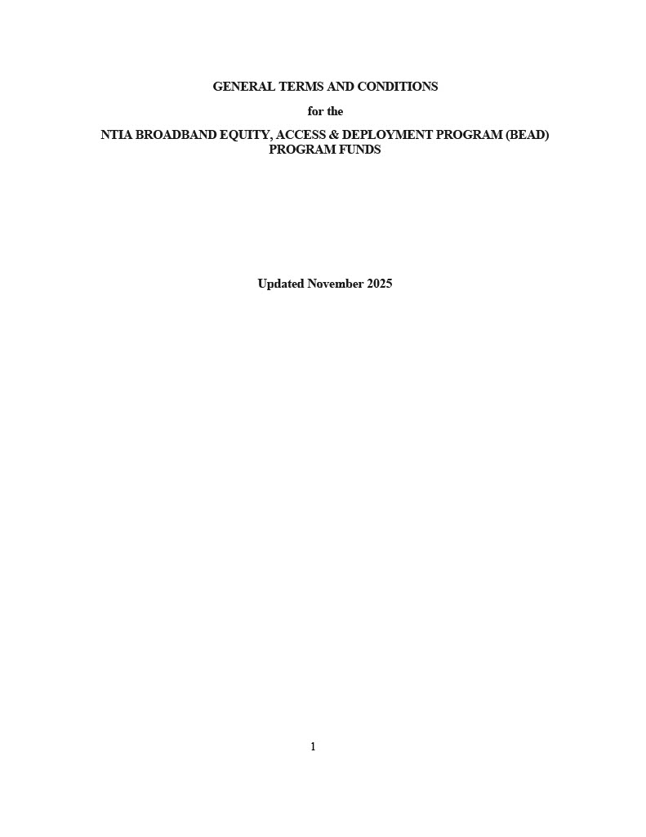
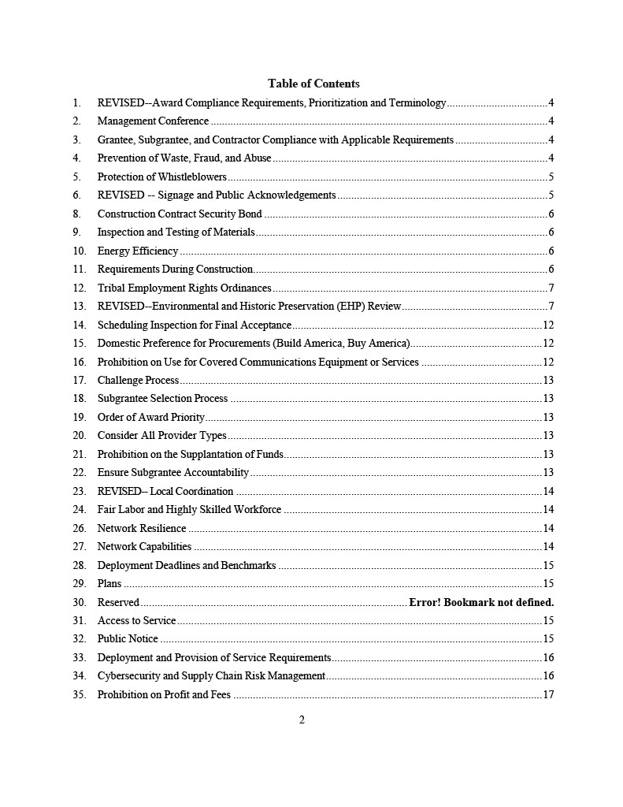

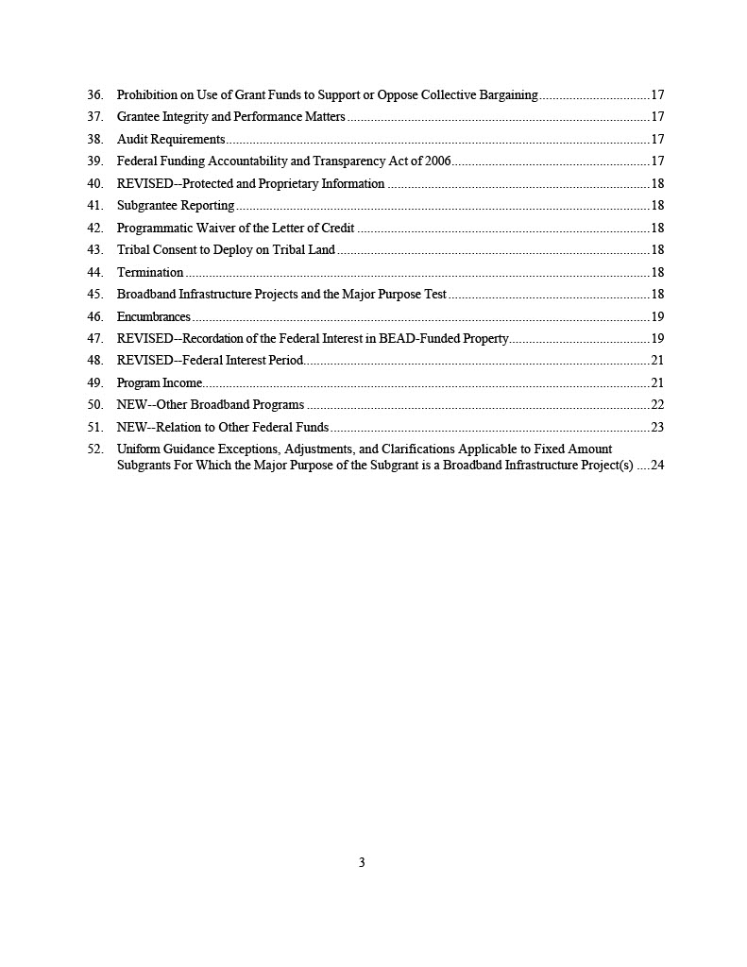

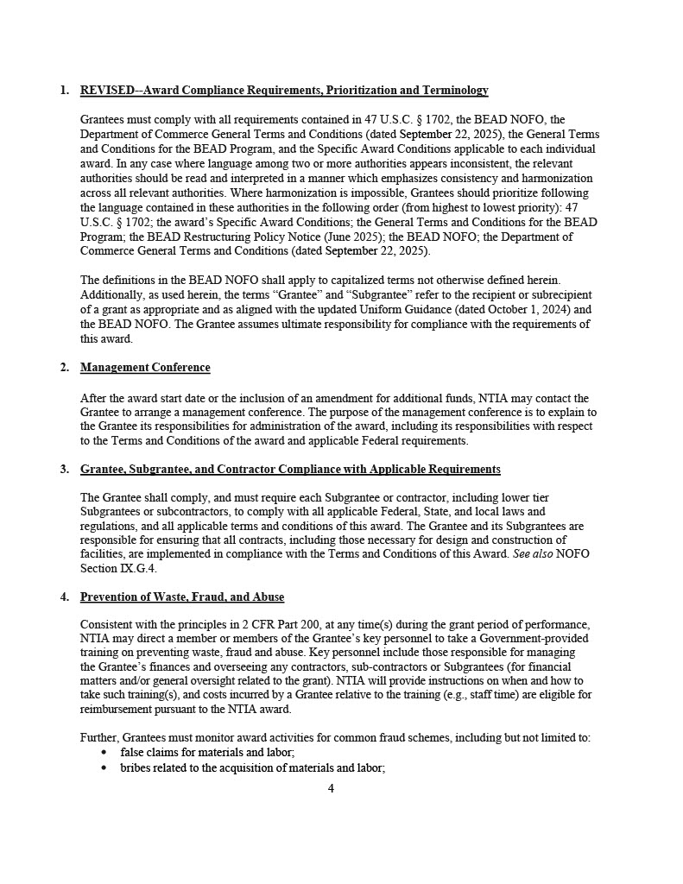

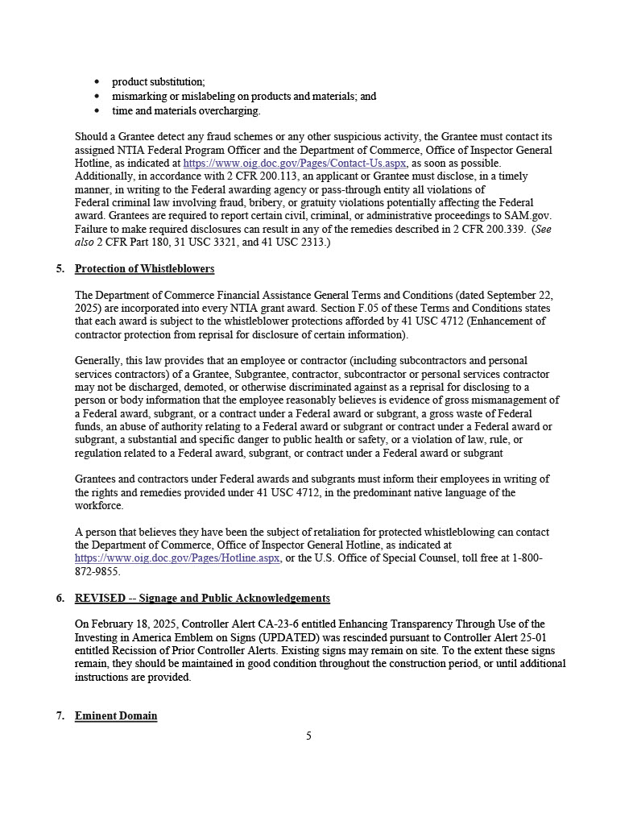

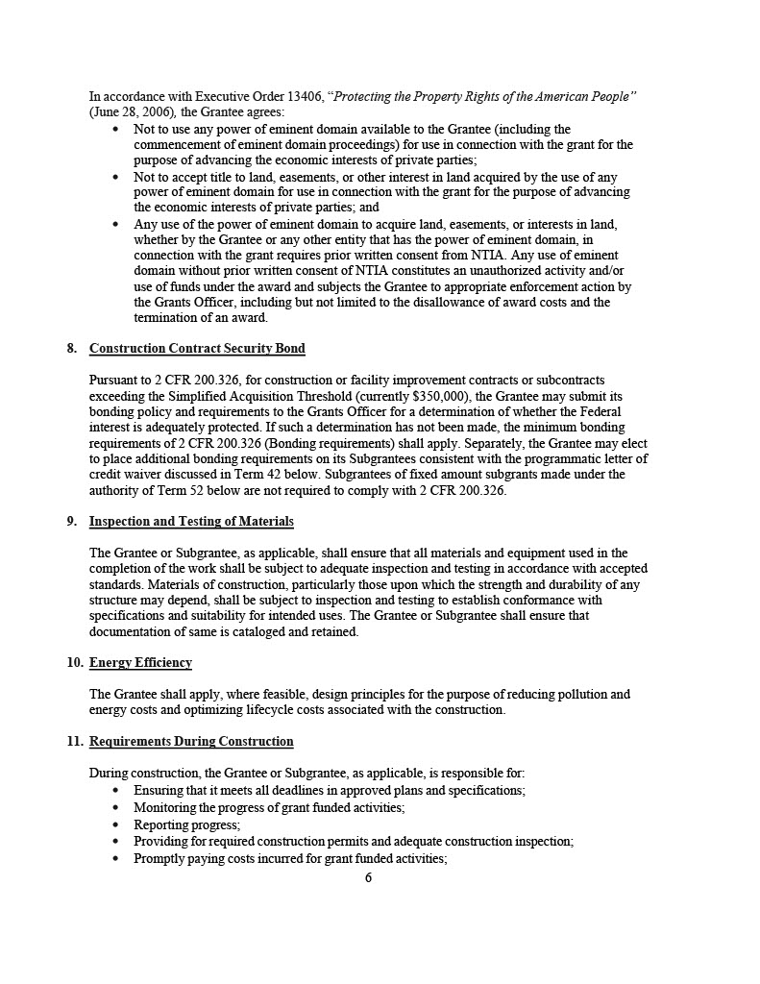

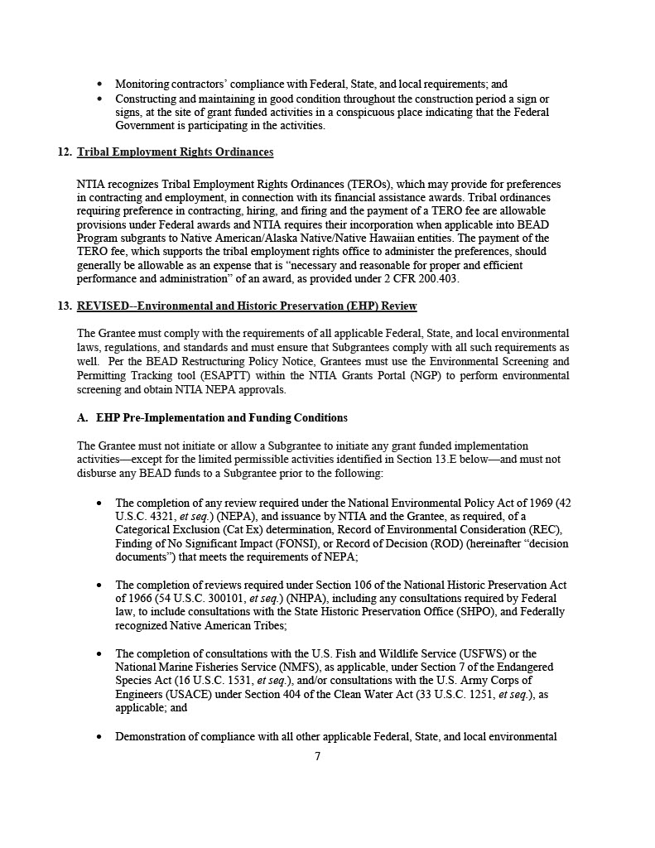

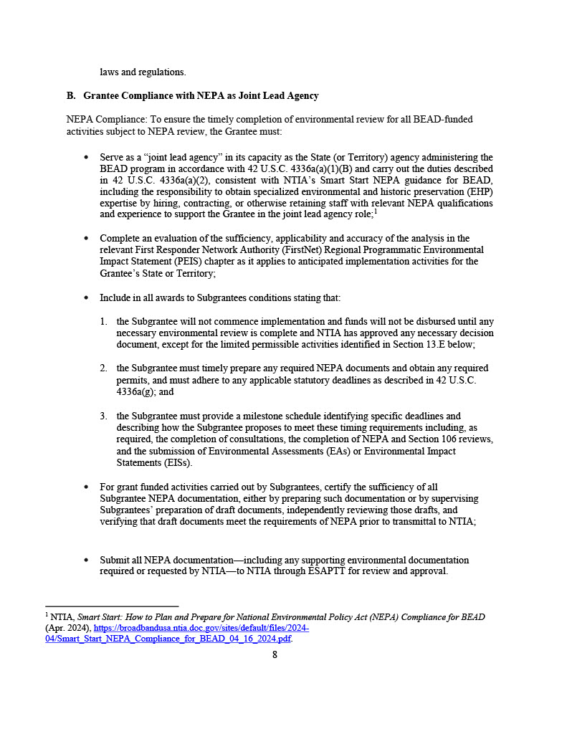

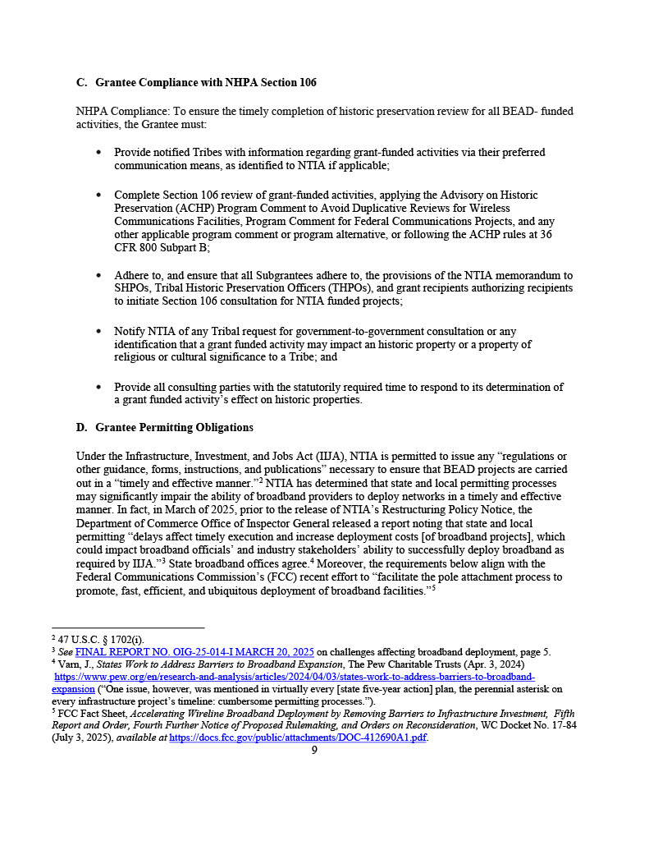

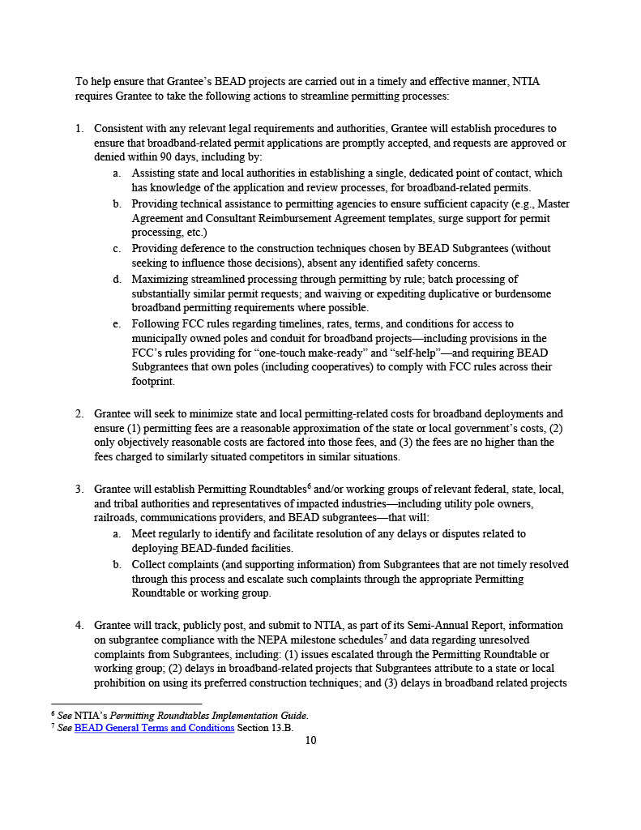

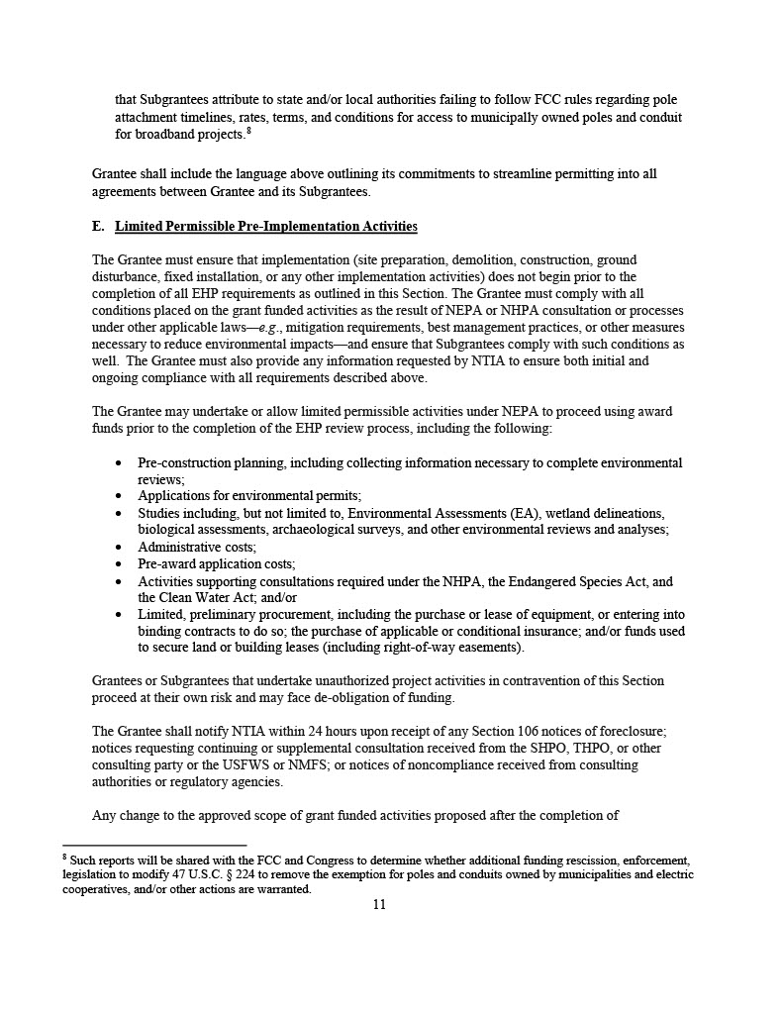

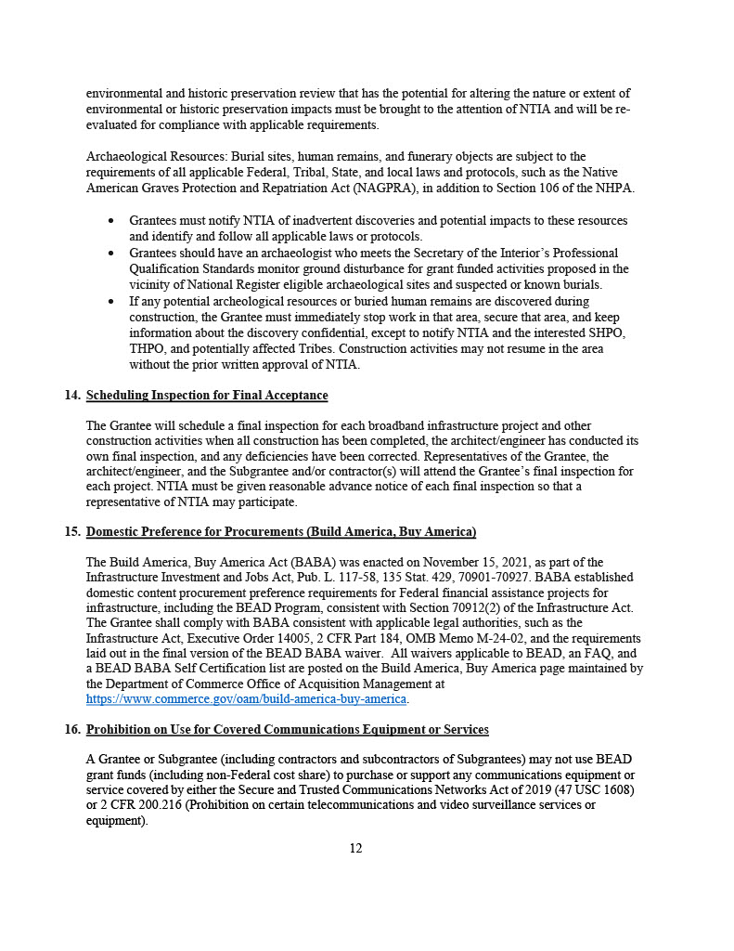

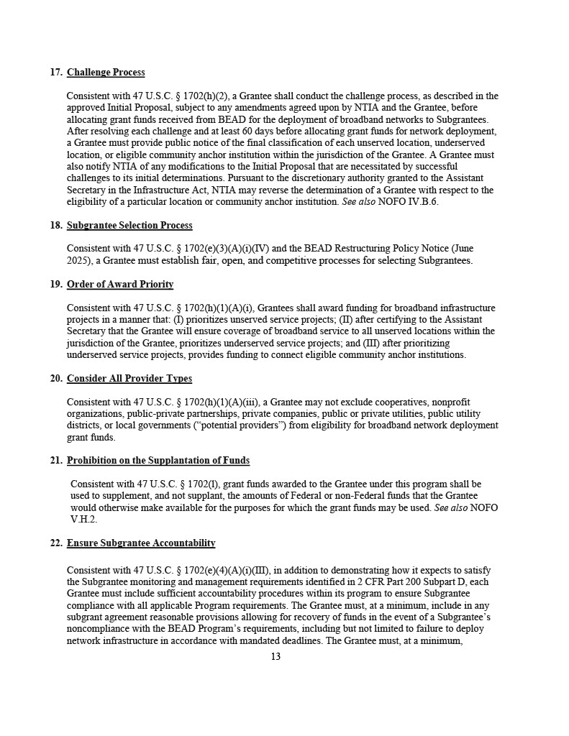

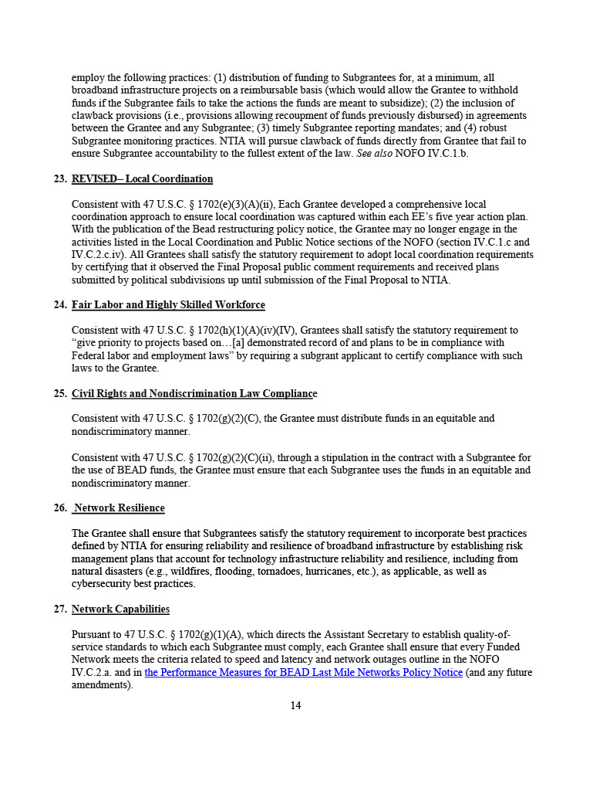

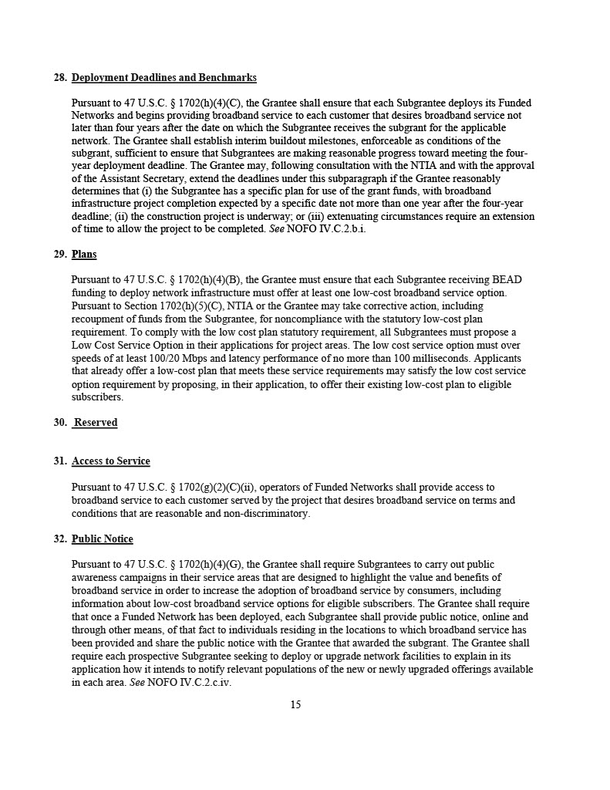

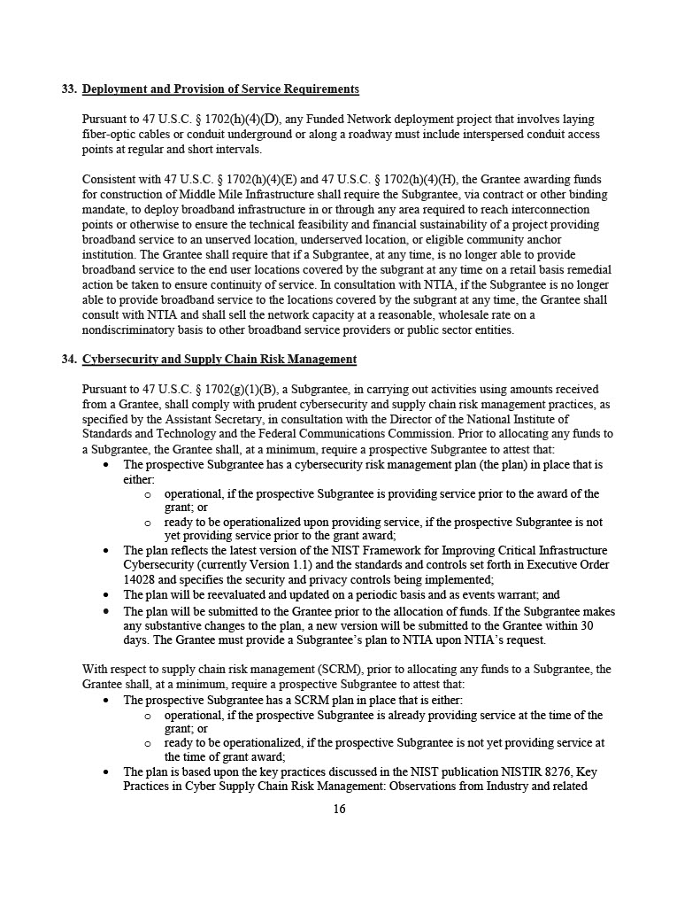

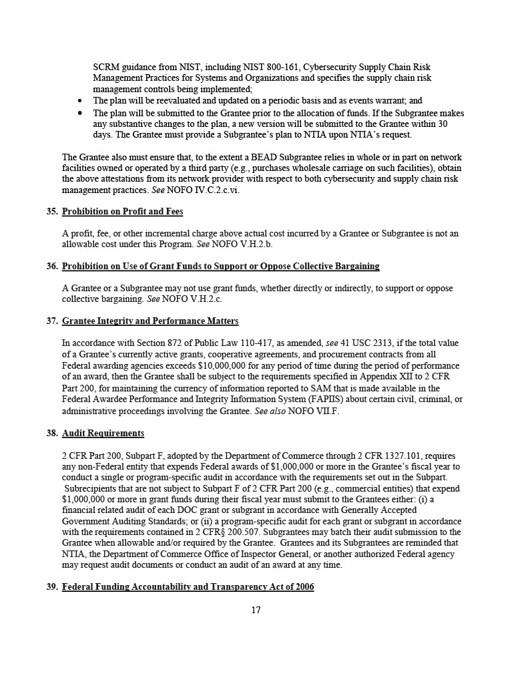

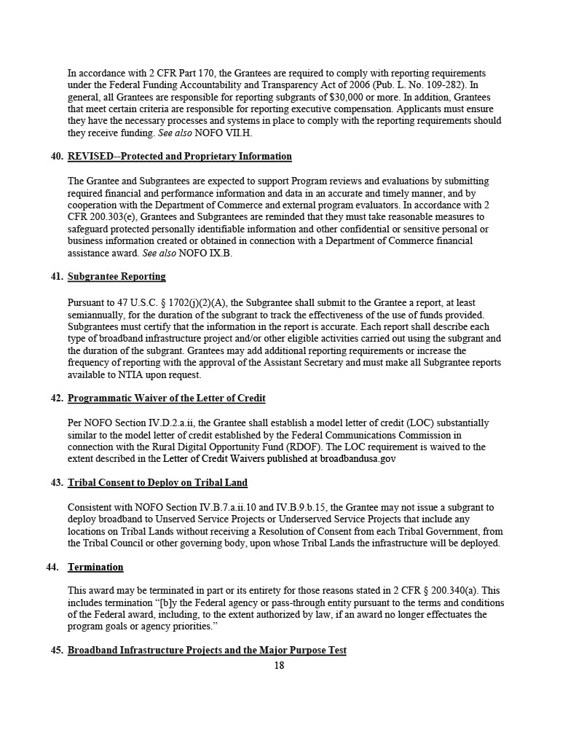

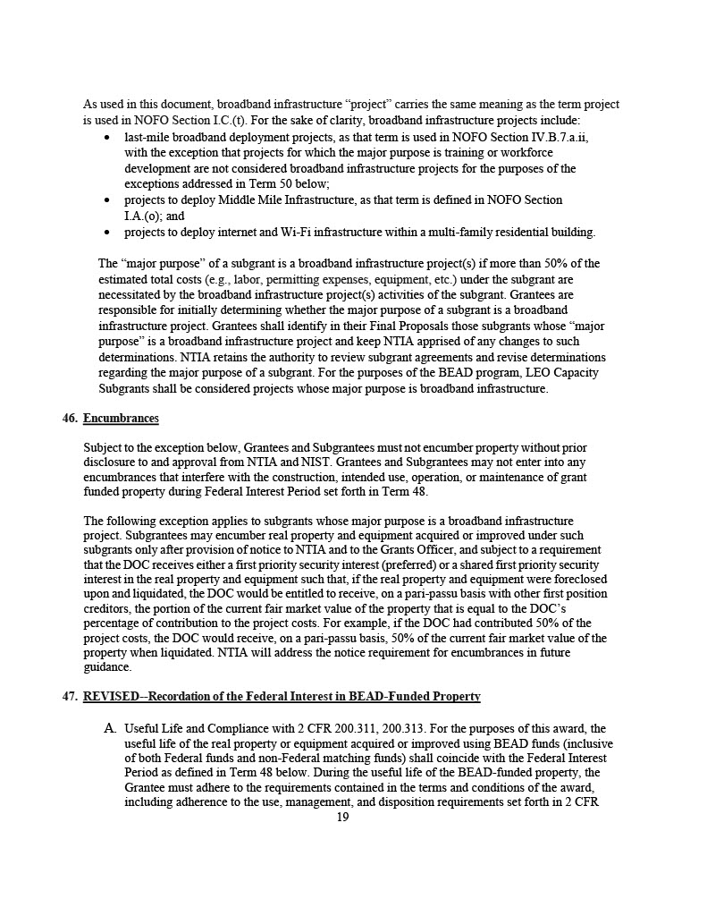

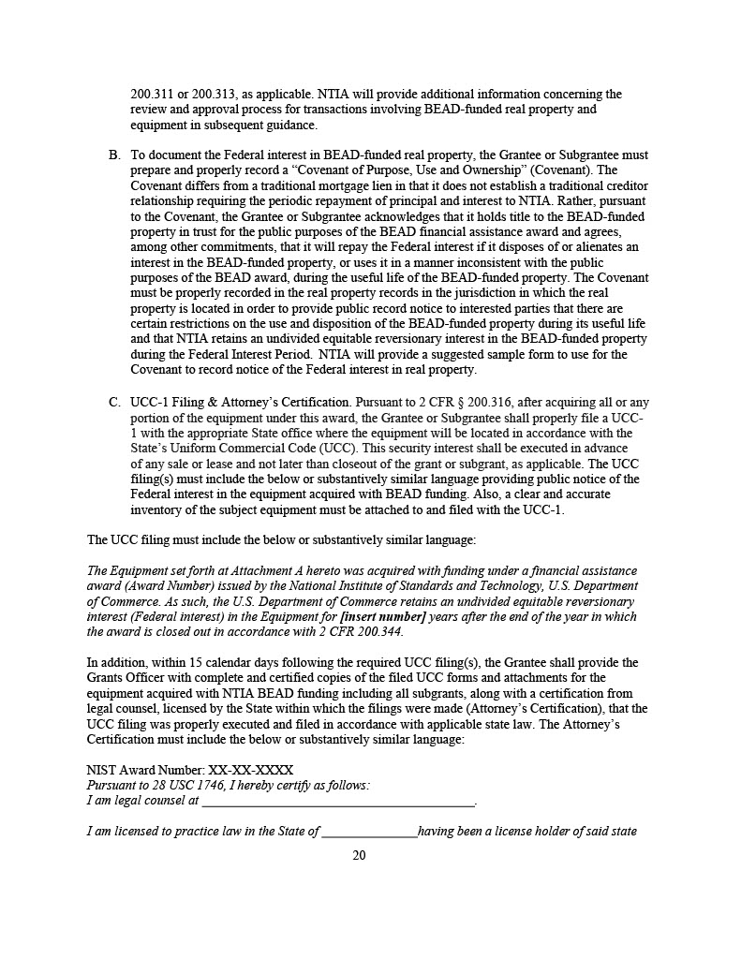

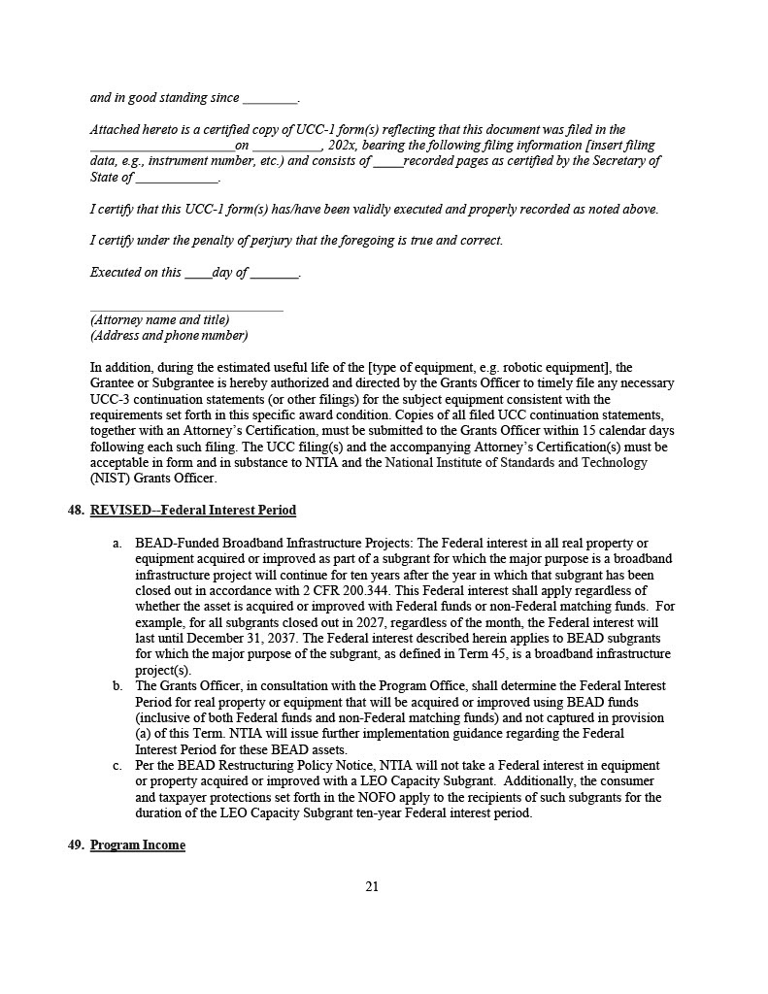

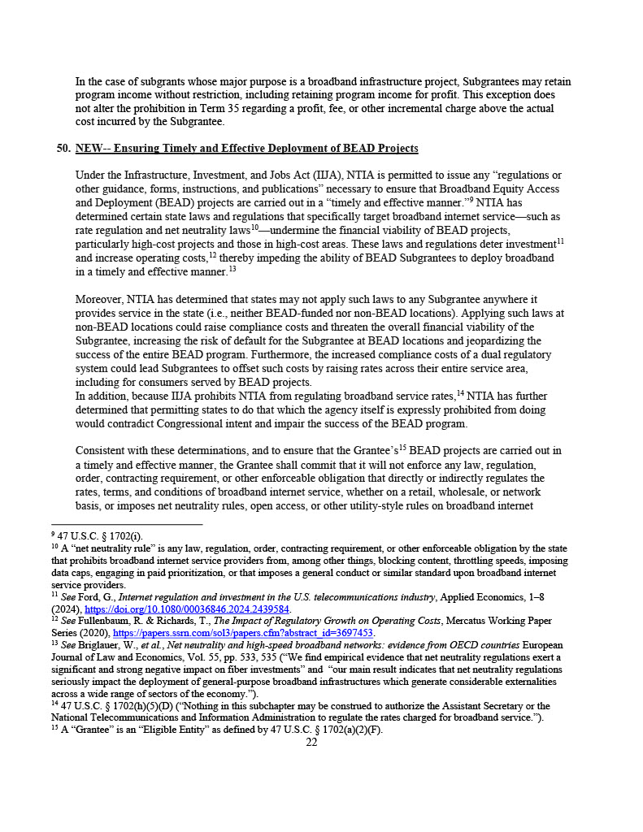

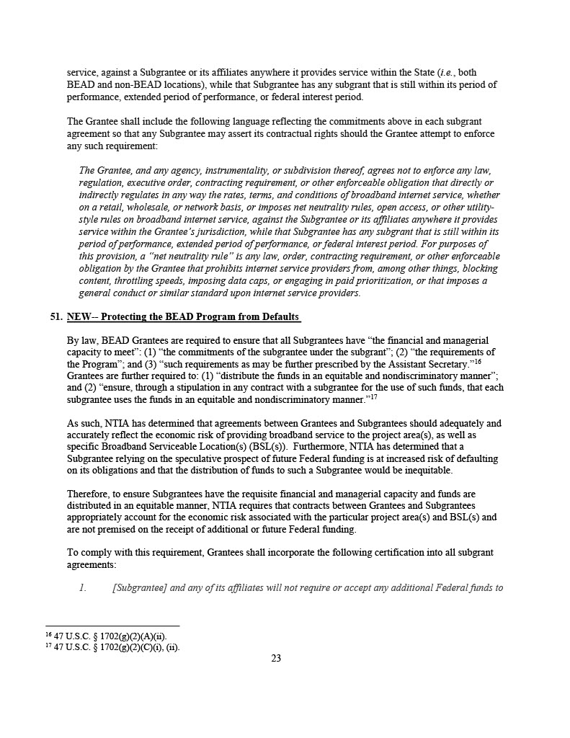

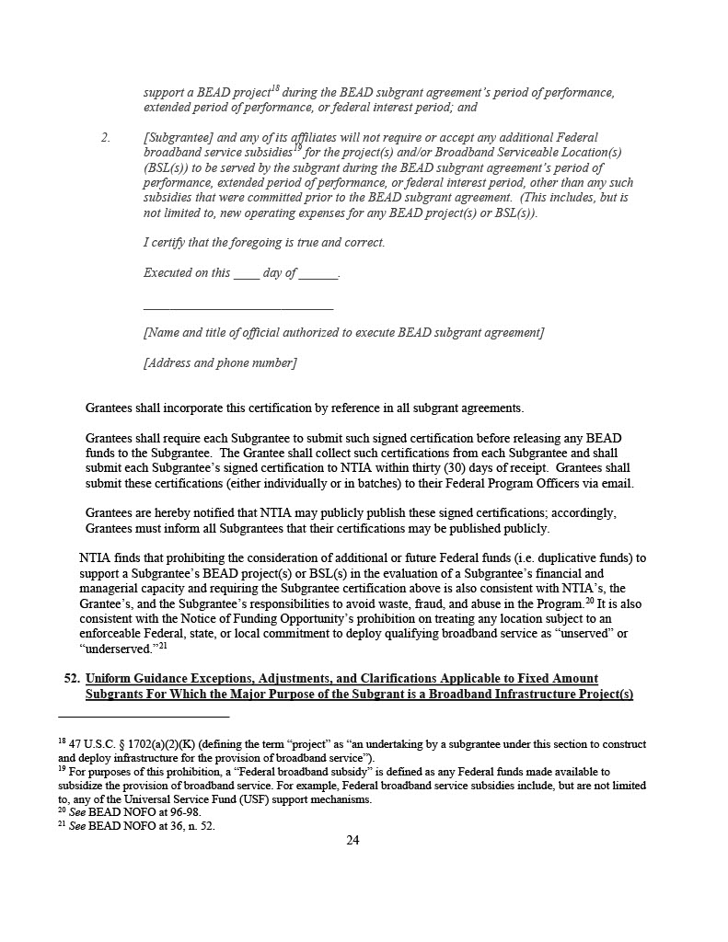

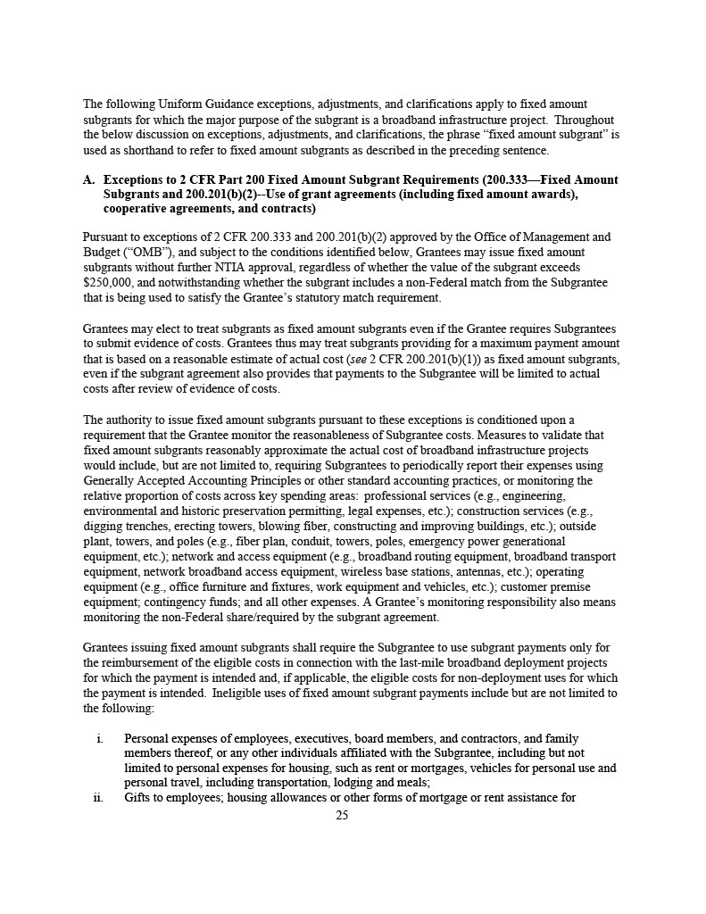

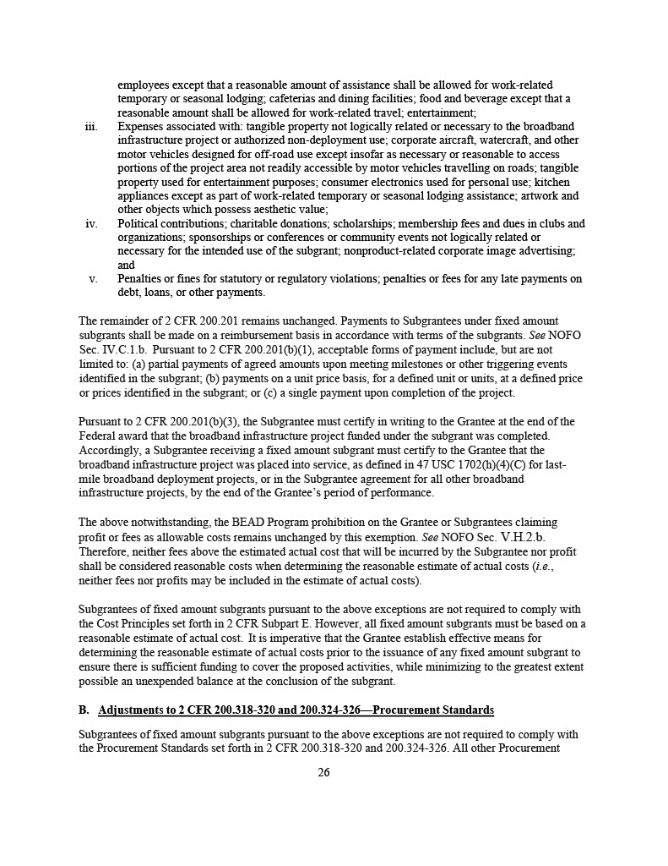

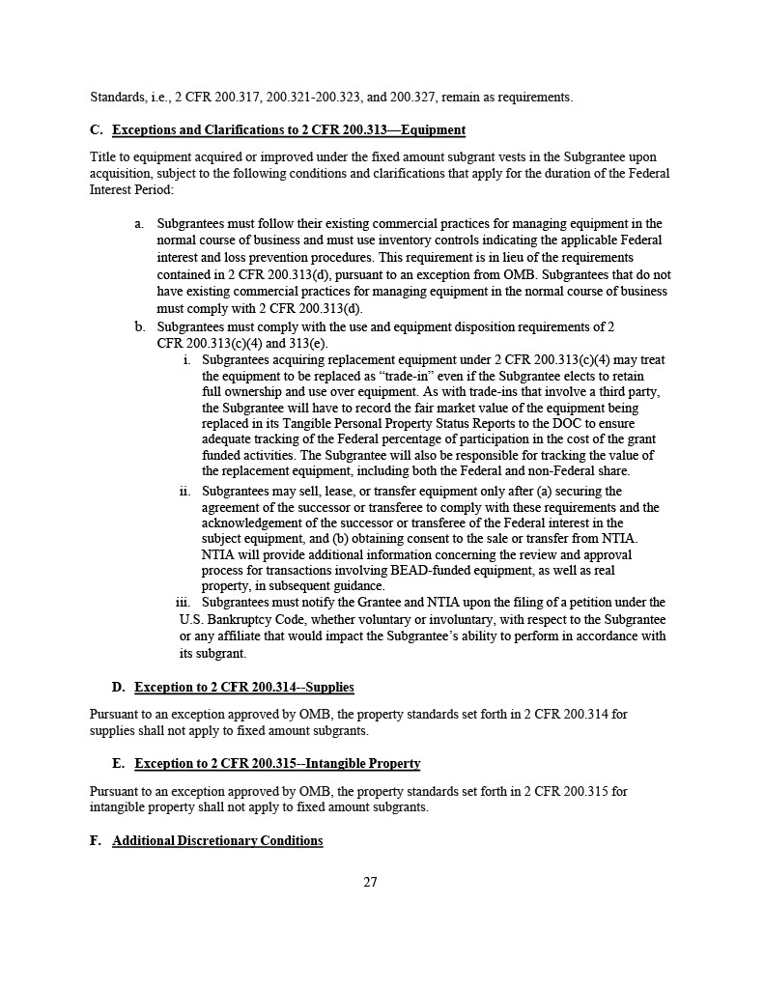

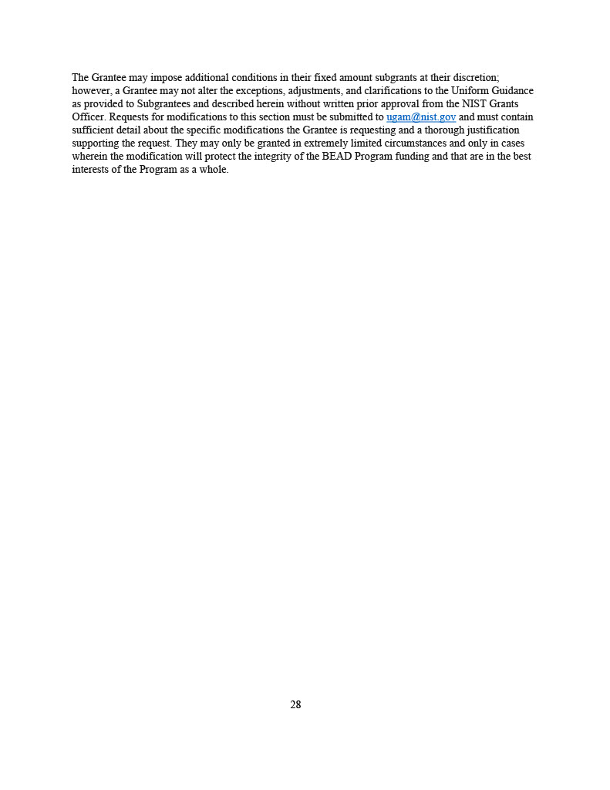
Exhibit G

PROTECTING THE BEAD PROGRAM FROM DEFAULTS CERTIFICATION

The undersigned certifies, to the best of his or her knowledge and belief, that:

1. For the project awards described in each of Subgrantee’s Applications and its Subgrant Agreement, Subgrantee and any of its affiliates will not require or accept any additional Federal funds to support a BEAD project during the BEAD Subgrant Agreement’s period of performance, extended period of performance, or federal interest period; and

2. For the project awards described in each of Subgrantee’s Applications and its Subgrant Agreement, Subgrantee and any of its affiliates will not accept any additional Federal broadband service subsidies for the project(s) and/or Broadband Serviceable Location(s) (BSL(s)) to be served by the Subgrantee during the BEAD Subgrant Agreement’s period of performance, extended period of performance, or federal interest period, other than any such subsidies that were committed prior to the BEAD Subgrant Agreement. (This includes, but is not limited to, new operating expenses for any BEAD project(s) or BSL(s)).

I certify that the foregoing is true and correct.

Executed on this day of , 20__.

[Name & Title of Individual Authorized to Execute the Subgrant Agreement]
[Address]
[Telephone Number]
[Email Address]

Exhibit H
Broadband Serviceable Locations

Total locations:

Location ID | Project ID | Download/Upload (Mbps)

Exhibit J
Eligible Use Cost Breakdown

Project Information | Budget Details

Appendix 1
Federal Award Identification

Subgrant Award Details

Pass Through Agency

Pass Through Agency information applies to all federal awards included in this Agreement.

Arkansas State Broadband Office
Arkansas Department of Commerce
Arkansas Economic Development Commission
1 Commerce Way, Suite 601
Little Rock, AR 72202

Contact Information for Pass Through Agency
Glen Howie, Jr. (Director) | 501-682-2311
Lane Bailey (Programmatic) | 501-682-7384
Kimberly Young (Financial) | 501-682-7306

47 U.S.C. § 1702(a)(2)(K) (defining the term “project” as “an undertaking by a subgrantee under this section to construct and deploy infrastructure for the provision of broadband service”).
For purposes of this prohibition, a “Federal broadband subsidy” is defined as any Federal funds made available to subsidize the provision of broadband service. For example, Federal broadband service subsidies include, but are not limited to, any of the Universal Service Fund (USF) support mechanisms.

